**Attributes of body tag**

The following attributes are supported by body tag or element

1. Bgcolor
2. text
3. Background
4. Align
5. Leftmargin
6. Rightmargin
7. Topmargin
8. Bottonmargin
9. Alink
10. Vlink

**bgcolor:**

This attribute define the background color of body or webpage

These colors in HTML are represented in different formats

1. Color name
   1. Solid color names
   2. Shading color names
2. Color value

Solid color:

1. Red
2. Blue
3. Green
4. Pink
5. Yellow
6. Black
7. White

Shade colors:

1. Lightgreen
2. Lightblue

**Color Value:**

R 🡪 Red 🡪 0-255

G 🡪 Green 🡪 0-255

B 🡪 Blue 🡪 0-255

Color value is represented in two formats

1. Single digit format
2. Double digit format

This color value is prefix with #

This color value technically are called hexacode(hexadecimal value format)

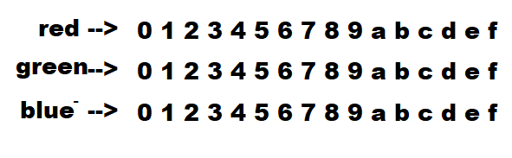

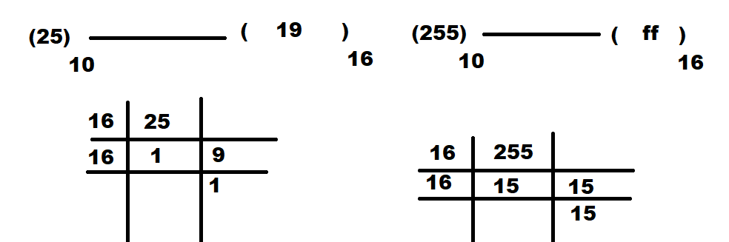

**Example:**

<body bgcolor=”red”>

<body bgcolor=”yellow”>

<body bgcolor=”lightblue”>

<body bgcolor=”#00f”>

<body bgcolor=”#a0b”>

<body bgcolor=”#a10000”>

<body bgcolor=”#aa00bb”>

**text**

This attribute is used to define font color or text color

**Example:**

<body text=”red”>

<body text=”#00ff00”>

**background**

This attribute is used to define background image

**Syntax:**

<body background=”images/imagename”>

**Image can be style used css styles**

1. Background-size
2. Background-repeat
3. Background-position
4. Background-attachment

**Syntax:**

<style>

body

{

Background-size: width,height,cover,contain

Background-position: top, bottom, left, right,center

Background-repeat: no-repeat,repeat,repeat-x,repeat-y

Background-attachment : scroll,fixed

}

**align**

This is used for alignment of text

The value of alignment is

1. Left
2. Right
3. Center
4. Justify

<!DOCTYPE *html*>

<html *lang*="en">

<head>

    <meta *charset*="UTF-8">

    <meta *name*="viewport" *content*="width=device-width, initial-scale=1.0">

    <title>Layout Demo</title>

    <style>

        div{

            border: 2px black solid;

            margin: 10px;

            padding: 5px;

        }

        body

        {

            height: 100vh;

            background-repeat: no-repeat;

            background-position: center center;

            background-size: 500px 500px;

            background-attachment:fixed;

        }

    </style>

</head>

<body *background*="images/banner.avif" *text*="yellow">

    <div>

        Full Stack Python

        <div>

            Module-1 Python

            <div>

                Core Python

                <div>

                    Python <span>Language</span> Fundamentals

                </div>

            </div>

            <div>

                Adv Python

                <div>

                    OOP, Database, Exceptions<br>

                    Files, GUI, Date Time

                </div>

            </div>

        </div>

        <div>

            Module-2 FrontEnd

            <div>

                HTML

                <div>

                    Creating Web Pages

                </div>

                <div>

                    CSS

                    <div>

                        Styling Web Pages

                    </div>

                </div>

            </div>

        </div>

    </div>

    <div>

        Full Stack Python

        <div>

            Module-1 Python

            <div>

                Core Python

                <div>

                    Python <span>Language</span> Fundamentals

                </div>

            </div>

            <div>

                Adv Python

                <div>

                    OOP, Database, Exceptions<br>

                    Files, GUI, Date Time

                </div>

            </div>

        </div>

        <div>

            Module-2 FrontEnd

            <div>

                HTML

                <div>

                    Creating Web Pages

                </div>

                <div>

                    CSS

                    <div>

                        Styling Web Pages

                    </div>

                </div>

            </div>

        </div>

    </div>

</body>

</html>

[pythonbygupta@gmail.com](mailto:pythonbygupta@gmail.com)

codewithsatishgupta 🡪 telegram